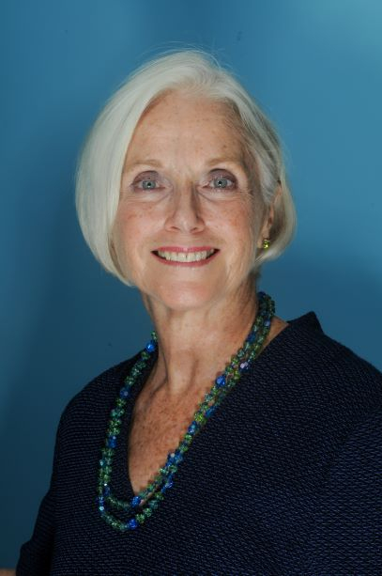 Biography of Judge Gale E. Rasin
Judge Gale E. Rasin served on Baltimore City’s trial courts for more than twenty years (April 1992 to September 2003, District Court for Baltimore City; September 2004 to August 2012, Circuit Court for Baltimore City). She also has served on panels by special designation on the Maryland Court of Special Appeals.

As a judge she presided over civil, family, domestic violence, and criminal cases, and created the first felony mental health court in Maryland. Since her retirement Judge Rasin has been recalled to sit as a Senior Judge. She also serves as a private mediator and arbitrator.

Judge Rasin has been active with organizations devoted to combating animal abuse and neglect. She served on the Baltimore City Mayor’s Anti-Animal Abuse Advisory Commission, created judicial training programs on animal cruelty, and has lectured several times at the annual animal cruelty conference of the Association of Prosecuting Attorneys. In 2019 she has been a Fellow at the Harvard Law School Animal Law and Policy Program.

She continues to preside over the Mental Health Court in the Circuit Court for Baltimore City, where she decides issues of competency and criminal responsibility, and monitors mentally ill defendants on probation. She is a member of the Judicial Conference Specialty Court’s Subcommittee on Behavioral Health and Developmental Disabilities.

Before going on the bench Judge Rasin was the Director of the Maryland Attorney General’s Office Medicaid Fraud Control Unit where she investigated and prosecuted cases of medical provider fraud and patient abuse. Before taking that position she was an associate at the (then named) firm of Piper & Marbury. She also served as an Assistant United States Attorney for the District of Maryland where she handled both civil and criminal cases and also served as an Assistant State’s Attorney for Anne Arundel County, Maryland.

She graduated from Duke University (magna cum laude, Phi Beta Kappa), and Georgetown University Law Center.

She lives on the Eastern Shore of Maryland.

