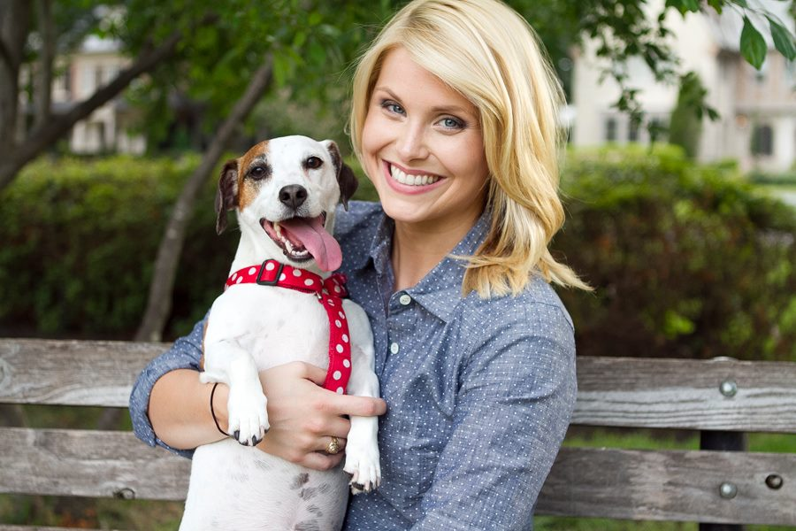

Bio-Katie Jarl
Katie Jarl, Southwest Regional Director, The Humane Society of the United States, has been with HSUS since 2010, first serving as the Deputy Director of HSUS’ media relations department. Jarl moved back to Texas in 2012 to direct public policy for the state and has successfully worked on laws to regulate puppy mills, crack down on cockfighting, keep horse slaughter out of Texas, end the cruel shark fin trade and make bestiality a felony in Texas. She works with local city governments to pass meaningful ordinances to help animals and she currently serves on both the Austin Animal Advisory Commission and the San Antonio Animal Advisory Commission. She managed on-the-ground efforts throughout HSUS’ response to Hurricane Harvey. Jarl now serves as the Southwest Regional Director for HSUS, including the states of Texas, Arizona, Colorado, New Mexico, Oklahoma, Louisiana, Arkansas, Kansas, Mississippi and Missouri.

