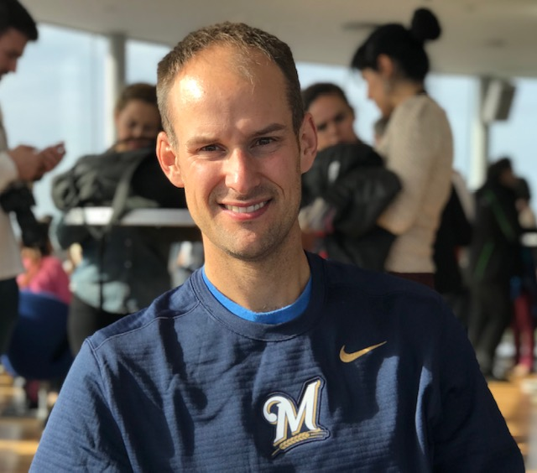

Nick Heitman is a 2009 graduate of Marquette law school and was briefly in private practice before joining the Milwaukee County District Attorney’s Office in 2010. Nick was assigned to the domestic violence unit when he started. Since that time Nick has become the head of the domestic violence unit. Nick has presented locally, statewide, and nationally about domestic violence prosecution. Currently, Nick is a member of the Milwaukee County Domestic Abuse High Risk Team, which meets weekly to review the most lethal cases that have occurred in the past week. Nick works closely with community partners, such as the sojourner family peace center to help with the struggle against domestic abuse. Nick is also a trainer of law enforcement officers regarding investigation tactics involving domestic abuse incidents. Nick has trained law enforcement on evidence gathering, stalking, and witness intimidation. Nick also holds a position with the Wisconsin Department of Justice as a Violence Against Women Resource Prosecutor. In this position Nick serves the entire south eastern region of Wisconsin as a resource for prosecutors and law enforcement regarding crimes against women. In this role Nick helps the surrounding communities develop and maintain a Sexual Assault response team, Domestic Abuse response team and other coordinated community response teams.

