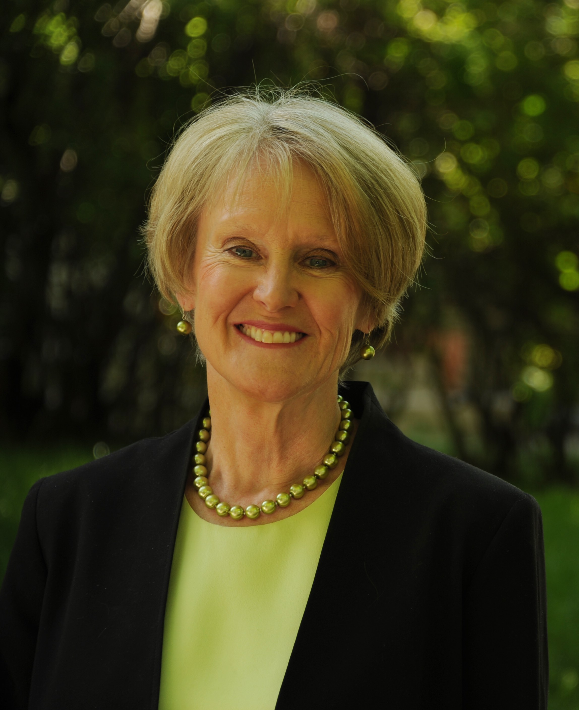
MEET THE DENVER DISTRICT ATTORNEY

Beth McCann was elected District Attorney of Denver in November 2016 and was sworn into office on January 10, 2017. She is the first female District Attorney in Denver’s history. Beth brings extensive prosecutorial, legal and managerial experience, proven leadership, and community perspective to the Denver DA’s office.

Immediately prior to becoming District Attorney, Beth was the four-term state representative for House District 8 in central and northeast Denver. McCann was a leader in criminal justice matters and health care reform throughout her legislative career.
Beth McCann began her legal career as a law clerk for Colorado’s U.S. District Court Judge Sherman G. Finesilver. She then served almost eight years as a deputy and then Chief Deputy District Attorney in Denver, prosecuting hundreds of cases, including child abuse and murders.
Her career included eight years in private practice with the Denver law firm of Cooper & Kelley, and she earned a partnership in that firm in 1985.
McCann was Denver’s first female Manager of Safety in the early 1990s under Mayor Wellington Webb, and the first director of Denver’s Safe City program to help kids stay out of gangs, drugs and violence. Juvenile crime decreased by over 20% following the establishment of this program.

Before becoming a state legislator, Beth McCann was Deputy Attorney General for Civil Litigation and Employment Law in the Colorado Attorney General’s Office for 8 years, supervising 33 trial lawyers as well as their support staff.

Beth McCann is a founding member and former president of the Colorado Women’s Bar Association, served as first Vice-President of the Denver Bar Association and was on the Board of Governors of the Colorado Bar Association. She also served on the Colorado Supreme Court/Court of Appeals Nominating Commission, and was a member of the Colorado Commission on Criminal and Juvenile Justice. She was chair of the Safety and Security Committee at Denver East High School and a coach of East’s Constitutional Scholars team. McCann also served on Governor John Hickenlooper’s transition team as a member of his public safety committee and on Denver Mayor Michael Hancock’s search committee for a new chief of police.

McCann graduated magna cum laude from Wittenberg University in Ohio with a B.A. in American Studies, and earned her law degree from Georgetown University Law School. Beth and her husband Christopher have two children, Chris and Lizzy, both Denver East High and Amherst College (MA) graduates.

