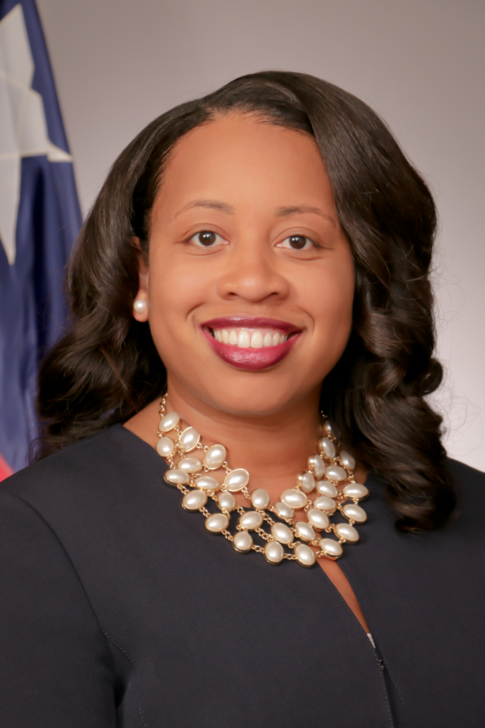 Carvana Cloud, is an Asst. District Attorney and Division Chief of the Family Criminal Law Division of the Harris County District Attorney’s Office, located in Houston, TX. Fluent in Spanish, Carvana graduated from The Kinkaid School and received her Bachelor of Arts degree from DePauw University and Doctor of Jurisprudence from South Texas College of Law. Recognizing that domestic violence in a significant crime driver, Carvana is committed to improving public safety by employing innovative prosecution strategies designed to ensure victim safety and enhanced offender accountability. In her current capacity, Carvana manages a multi-disciplinary team of prosecutors, social workers, and investigators committed to seeking justice for victims of domestic violence. Carvana has extensive trial experience litigating crimes against cases people, and specifically domestic violence cases, having served as a felony prosecutor in the Family Criminal Law Division she now leads. Committed to eradicating the cycle of violence in the family unit, in December 2017, Carvana created the Harris County Strangulation Taskforce, which is a workgroup of law enforcement agencies and community stakeholders committed to developing a countywide protocol for the investigation and prosecution of strangulation cases.

Prior to joining the Harris County District Attorney’s Office as a baby lawyer in 2005, Carvana served in the Office of the White House Liaison to the United States Department of Commerce, as an intern to United States District Judge Lynn Hughes, and as a briefing attorney for United States District Judge George C. Hanks Jr. Carvana proudly returned to the Harris County District Attorney’s Office in January 2017, after founding and operating The Cloud Law Firm, P.C., a boutique law firm focusing on criminal defense, immigration, and personal injury matters. A native Houstonian, Carvana serves as board secretary of Houston’s Fourth Ward Redevelopment Authority, Tax Reinvestment Zone (TIRZ) #14 and is a member of Alpha Kappa Alpha Sorority Inc., the nation’s oldest sorority founded by and for Africa-American women. In 2014, Carvana was recognized as one of Houston’s Top 50 attorneys by Dmars.com.

A community ambassador for victims of interpersonal violence, and particularly underserved minorities, Carvana is a regular speaker and trainer for local churches, civic groups, and law enforcement organizations inspiring and motivating community leaders and industry professionals to develop coordinated community responses that will offer crime victims “concierge style” customer service, so they can be protected and empowered to live a life free of violence and abuse. Carvana is married to Willie and they have two children.

