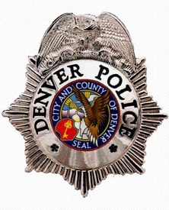

PAUL M. PAZEN
CHIEF of POLICE
DENVER POLICE DEPARTMENT

On Monday, July 9, 2018, Paul M. Pazen was sworn in as the 70th Chief of Police for the Denver Police Department. Chief Pazen began serving the Denver community as a police officer in 1995 and his experience includes 12 years of command level experience in several areas of police operations. For the six years prior to his appointment to Chief of Police, Chief Pazen was the Commander of District One, during which he led an ambitious effort to enhance police services, create an environment of team building, collaboration, and fostering innovative crime prevention strategies, while instituting transparency and accountability, and empowering residents and sustainable community/police relations.

Chief Pazen is a proud Denver native and graduate of Denver’s North High School, after which he served with the United States Marine Corps and is a Gulf War Veteran. He earned a Bachelor of Science degree in Organizational Leadership from Colorado State University-Global and graduated with magna cum laude honors. Chief Pazen continues building his skills through training and education including the Senior Management Institute for Police, Police Executive Forum at Boston University, Federal Bureau of Investigation-National Academy (FBINA), West Point Military Academy-Leadership in Police Organizations Instructor, Criminal Justice Certificate from University of Virginia, and 2018 Fellow at University of Denver, Latino Leadership Institute.

Chief Pazen has received various high-level department awards and commendations for managing critical incidents, implementing strategic planning and full-scale preparedness exercises, execution and evaluation. Commendations include the Distinguished Service Cross, Leadership Award, Superior Tactics and Response Award, Police Merit and Department Service Award.

