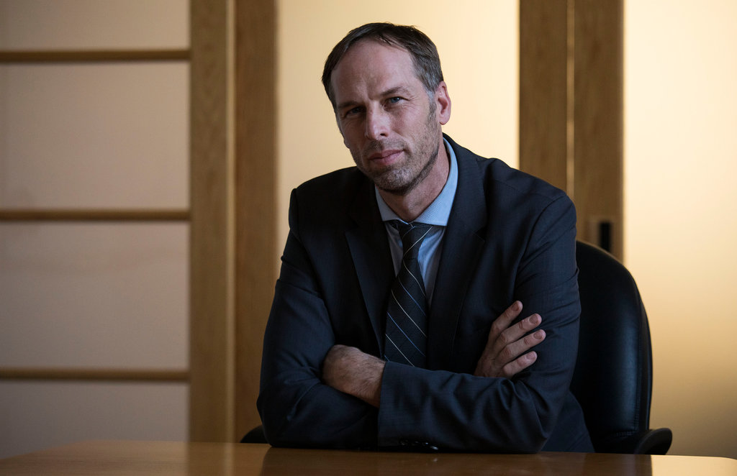

Christopher Anderson is the Director of the Domestic Violence Unit at the Seattle City Attorney's Office where he manages a team of assistant City Prosecutors and victim advocates that prosecute over 1500 domestic violence cases in the City of Seattle a year. Chris is also the Co-Chair of the Regional Domestic Violence Firearms Enforcement Unit— a multi-jurisdictional and multi-disciplinary unit of police officers, prosecutors, victim advocates and paralegals dedicated to removing firearms from domestic abusers and individuals subject to extreme risk protection orders.

Chris started his career in the King County Prosecutor's Office as a deputy prosecutor prosecuting felonies in the domestic violence unit, juvenile division, trial teams unit, and was a supervisor in the district court unit. He was also a member of the complex prosecutions and investigations division, currently the special operations unit responsible for investigating and prosecuting complex fraud and elder abuse cases. He joined the City Attorney’s Office in 2015 as the Director of the Domestic Violence Unit. Chris has been an adjunct professor at Seattle University, a guest speaker at the Domestic Violence Symposium at Seattle University in 2016 and 2017, the 2017 National Gun Violence Prevention Conference in Washington DC in 2018, and the Gun Violence Summit in Seattle, Tacoma and Spokane in 2018 and 2019. Chris is an active member of the Domestic Violence Prevention Council and Criminal Justice Committee.

